A 262 TOPS Hyperdimensional Photonic AI Accelerator powered by a Si3N4 microcomb laser: Supplemental Document
Christos Pappas, Antonios Prapas, Theodoros Moschos, Manos Kirtas, Odysseas Asimopoulos, Apostolos Tsakyridis, Miltiadis Moralis-Pegios, Chris Vagionas, Nikolaos Passalis, Cagri Ozdilek, Timofey Shpakovsky, Alain Yuji Takabayashi, John D. Jost, Maxim Karpov, Anastasios Tefas and Nikos Pleros
*chripapp@csd.auth.gr
S1. Pre-emphasis process towards linearizing the photonic link
Following the setup procedure of the experimental testbed, and prior executing the multiplication for the NN models, we carried out a preliminary testing for evaluating the performance of the multiplication operations. Initially, each Mach-Zehnder modulator (MZM) of the experimental setup (described in the section: Experimental Validation through DL applications of the main manuscript) was driven by a PAM4 electrical signal, capturing their response in a real time oscilloscope (RTO). The initial performance indicated a mismatch between the expected and the received values, as the 4 ideal levels were mixed. This is due to two factors: (i) the noise originating from the limited frequency response of each channel-pair [RF driver - MZM], and (ii) the non-linear response introduced by the RF driver, MZM and PD combination. It is worth noting that the frequency response will change based on the operational data-rate, as opposed to the non-linear response which only accounts for the operational conditions, i.e., RF driver input power and MZM’s bias point. To mitigate the effects of both impairments, we investigated pre-emphasizing the signal using offline software at the transmitter site, which is a common digital signal processing procedure. As already mentioned, the nominal data-rate can affect the frequency response. Hence, a standard pre-emphasis of the frequency response of each [RF driver - MZM] pair was incorporated based on the operating speeds of 20 and 32 Gbaud, respectively. This pre-emphasis step involves applying a 7-tap digital linear feed-forward equalizer at each MZM output, with the produced taps being enforced to the original signal at the transmitter.
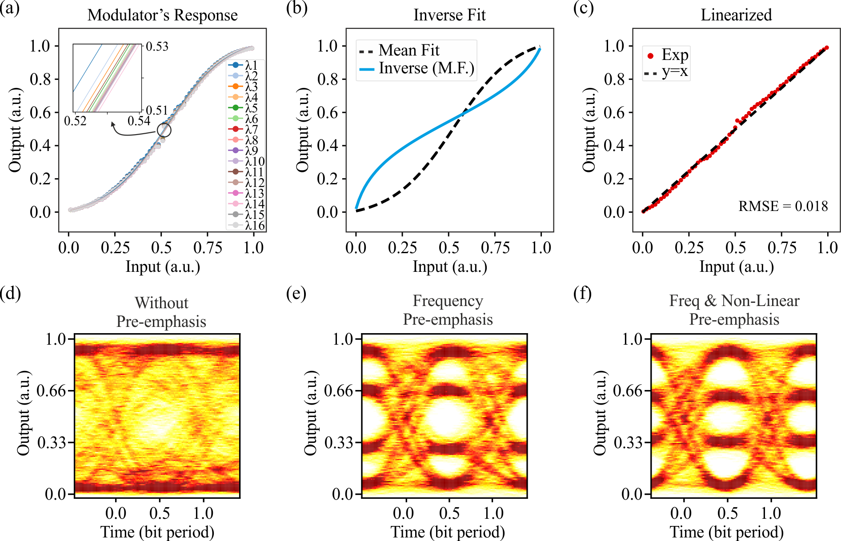
Supplementary Figure 1: Pre-emphasis procedure for frequency and non-linear compensation, (a) non-linear response of the MZM for the 16-wavelength channels with the zoomed-in inset showing the deviation of each wavelength, (b) mean fit of the 16-wavelength response with the respective inverse function applied to the transmitter, (c) linearized response after the non-linear compensation, (d) eye-diagram of a PAM4 signal without applying any pre-emphasis, (e) eye-diagram of the same PAM4 signal by applying the channel-frequency pre-emphasis, and (f) eye-diagram of the same PAM4 signal by applying channel-frequency pre-emphasis and non-linear compensation.
For the non-linear compensation that followed the frequency pre-emphasis, a custom multi-level signal was created that facilitated the procedure of extracting the transfer function (TF) – response of the electro-optic link. The custom electrical signal was designed as a linearly increasing and decreasing sequence of pulses oscillating over a DC value (zero) and was generated as: $Sequence=\left[0,+n,-n\right], n∈[1, 32]$. This signal enabled a 64-discrete-level resolution for the TF extraction. The non-linear components we accounted for were the non-linearities introduced by the RF driver, MZM and PD. Although the MZMs are broadband devices, the TF extraction considered the response of each one of the 16 wavelengths exploited experimentally, with the resulting transfer characteristic curves being illustrated in Sup. Fig. 1(a). The 16 wavelength-curves were separately captured for the same input power and bias conditions for the MZM, and were normalized in the range (0, 1). The graph reveals a small deviation between the mid-value points of the curves, as shown in the inset of the figure. For the 16 curves we calculated the mean fit, as presented in Sup. Fig. 1(b). Based on this, we extracted the inverse function and applied it to the ideal signal at the transmitter. The linearized response of the MZM is depicted in Sup. Fig. 1(c), where the experimentally derived points, are fit and closely aligned with the linear function exhibiting an RMSE of only 0.018. Finally, Sup. Figs. 1(d)-(f) illustrate the eye diagrams for the PAM4 signal when the MZM is driven at 20 Gbaud. Fig. 1(d) shows the eye diagram when neither pre-emphasis nor non-linear compensation are applied to the transmitter. Fig. 1(e) illustrates the PAM4 eye diagram when only frequency pre-emphasis applied, while Fig. 1(f) depicts the PAM4 eye diagram, when both frequency pre-emphasis and non-linear compensation are applied, clearly showcasing significant improvement over the original signal. The same procedure was also followed for the case of 32 Gbaud. After the channel-linearization procedure, we performed “dummy” multiplications between PAM4 signals, to extract the bit-resolution capabilities of the photonic hardware, when including real noise-sources. The resulting multiplications were captured and analysed for both operational rates. Following the principles described in [1], the noise-equivalent bit-resolution (NEB) was calculated as ~4.3 and ~3.5 at 20 and 32 GHz, respectively.
S2. Multi-wavelength operation validation
To validate the multi-wavelength operation across the experimental testbed, we obtained the optical spectra at four different points. These points are detailed within the small-scale representation of the experimental setup shown in Sup. Fig. 2(a), labeled as points A-D. These points were aptly selected to follow the basic experimental stages, i.e., after the wavelength (de)-multiplexing, W- and X-modulators and AWGR output. Supplementary Figure 2(b) illustrates the four different spectra, when modulating with 32 Gbaud data-rate. As it can be observed, the power levels among the 16 wavelengths are equalized at each modulation stage, in order to ensure consistent quality performance among the wavelength-carriers of the NN data. The multiplexer output spectrum at point A, shows that the wavelengths near 1536 nm have lower peak powers. This was engineered based on the gain curve of the subsequent erbium doped fiber amplifier (EDFA). The W-modulator output (point B) illustrates almost uniform peak powers across all available wavelengths, validating its broadband capabilities. The peak power distortion between the wavelengths at AWGR output spectrum (point C) owes to the unbalanced losses originating from the I/O ports of the AWGR module. To ensure a peak power-equalization at both the X-modulator input and output (point D), a wave-shaper was placed at the output of the AWGR in order to customize the attenuation per wavelength-channel. It is worth noting that the data rate of 32 Gbaud, was the maximum achievable based on the experimental devices we employed. As shown in Sup. Fig. 2(b) and spectrum-graph of point C, the wavelengths generated from the frequency comb laser were misaligned with the AWGR-channels. Consequently, an increase of the data-rate would result in information-loss due to the grid mismatch of the frequency comb and AWGR-channel. The frequency comb was already thermally tuned to the maximum achievable detuning (wavelength+Δλ), while the heaters of the AWGR module could not be adjusted due to a faulty control circuit.
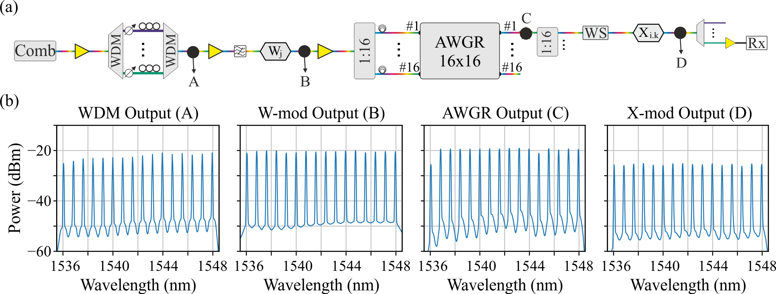
Supplementary Figure 2: (a) Small-scale experimental setup (detailed in main manuscript) denoting 4 different points (A-D) for spectrum capturing, and (b) Spectra at different points of the setup for the multiplexer output (A), W-mod output (B), AWGR output (C) and X-mod output (D).
S3. Power consumption breakdown
A SiPho/InP-based integrated version of the proposed N-channel AWGR architecture, could still follow the structure of the layout presented in Figure 1(a) of the Main Manuscript. This means that the photonic integrated circuit (PIC) would require a multi-wavelength laser source, two splitting stages (a 1: N splitter prior each modulation stage), high speed modulation nodes and the readout circuitry, i.e., transimpedance amplifiers (TIAs), integrators and analog-to-digital conversion (ADC) channels. As detailed in the Discussion section of the Main Manuscript, a viable alternative is through a multi-chiplet implementation. Following either integration path, the most appealing multi-wavelength laser source, in terms of footprint and energy efficiency, is the frequency comb laser, as also incorporated in this experimental demonstrator. Though, the current frequency comb implementation, which we considered for the analysis, is coming with a limitation in terms of the per wavelength-channel average power (~0.01mW) and thus we also need to account for amplification stages within the PIC. To determine the number of amplifiers, the required gain and their placement within the architecture, we first need to breakdown the insertion loss (IL) of the N-channel AWGR topology. The IL_{Total} can be calculated as: IL_{Total} = 2×IL_{MZM} + IL_{AWGR} + IL_{DeMUX} + 2×IL_{SPLIT(1:N)}. The only variable term of the equation that can affect the required number of amplifiers and their respective gain, is the term IL_{SPLIT(1:N)}, which is based on the variable N of the N-channel AWGR module. We considered semiconductor optical amplifiers (SOAs) as the amplification medium, with their total count per N-channel case with their respective gain, detailed within Supplementary Table 1. For every N-channel case, an SOA of gain 15 dB or 20 dB is assumed to be directly connected at the output of the frequency comb. For the 4- and 8-channel cases we assumed N SOAs connected to the N-outputs of the AWGR, while for the 16- and 32-channel cases, we considered N SOAs connected prior the first modulation stage to compensate for the 12- or 15-dB of IL introduced by the 1:16 or 1:32 splitter, respectively, and N SOAs placed at the N outputs of the AWGR to compensate for the IL of the subsequent 1:16 or 1:32 splitter. Supplementary Table 1 also contains the device considered for the calculations, along with the component count where appropriate, i.e., DAC, RF amplifier, TIA, integrator and ADC, along with their corresponding power consumption values. Based on the corresponding consumption metrics, the power consumption of the demonstrated 16×16 AWGR-based MbTM accelerator operating at 32 Gbaud data rate, can be quantified as 71.59 W. For the achieved computational power of 262 TOPS this power consumption translates to a respective energy efficiency of ~273 fJ/OP. Finally, the targeted MbTM accelerator will employ a 32×32 AWGR and use modulators with compute rate of 50 Gbaud. In this case, the power consumption adds up to 309.5 W and for the achieved computational power of 3.276 POPS the accelerator exhibits an energy efficiency of ~94 fJ/OP.
Supplementary Table 1: Power consumption and total count of the SiPho-based components considered for the N×N AWGR architecture.
Component | Reference | Consumption (mW) | Component Count
Frequency Comb |  | 1,000* | 1
DAC | [2] | 144 / 168✝ | N + N²
RF Amplifier | [3] | 100 | N + N²
SOA† | [4] | 42 / 84⁑ | 4×4 AWGR: N^{(15dB)} + 1^{(15dB)}
SOA† | [4] | 42 / 84⁑ | 8×8 AWGR: N^{(15dB)} + 1^{(20dB)}
SOA† | [4] | 42 / 84⁑ | 16×16 AWGR: 2×N^{(15dB)} + 1^{(15dB)}
SOA† | [4] | 42 / 84⁑ | 32×32 AWGR: 2×N^{(15dB)} + 1^{(20dB)}
TIA | [5] | 9/L⸸ | N³
Integrator | [6] | 0.44⸸ | N³
ADC | [7] | 0.56⸸ | N³
*Consumption is based on the targeted value of the future optimized Enlightra SLC frequency comb.
✝Consumption is based on the respective data-rate and is calculated as 144 mW (20/32G) or 168 mW (50G).
†Different SOA-gain is accounted based on the AWGR’s I/O (N×N) at the component count.
⁑Consumption is based on the respective gain and calculated as 42 mW ^{(15 dB)} or 84 mW ^{(20 dB)}.
⸸The readout circuitry needs to operate in a sub-GHz speed, as it will be active only once every L time-steps.

S4. Computational power and parameter-load rate
The computational power of the proposed AWGR-based accelerator is defined as the arithmetic throughput (T) in operations per second (OPS), counting one multiply plus one add as two operations (MAC = 2 ops). We assume an 𝑁×𝑁 AWGR which is fully populated with 𝑁 comb lines and on the same time, each output is split in N components (S = N). This generates an input × output count of 𝑁×𝑁². For a symbol rate of B Gbaud, the total throughput of the AWGR-based topology can be calculated as 𝑇=2×𝑁×N²×𝐵 (OPS). Under this rule, Supplementary Table 2 summarizes the total demonstrated and potential computational powers. As such, the 16×16-AWGR system delivers a throughput of T = 2×16×16²×20×10⁹ (OPS) = 163.8 TOPS for 20 Gbaud operation. Following the same calculation process, our demonstrator while operating at 32 Gbaud achieved 262.1 TOPS. Extrapolating the same architecture to a 32×32 AWGR, it can yield 1.31 POPS at 20 Gbaud, 2.10 POPS at 32 Gbaud, and 3.28 POPS at 50 Gbaud (where 1 TOPS = 10¹² ops/s and 1 POPS = 10¹⁵ ops/s). These values assume all routed paths are active simultaneously.
Supplementary Table 2: Throughput values of the Demonstrated and the Potential AWGR-based accelerators.
 | Data Rate | Comb lines | AWGR Size | Throughput (TOPS*)
Case | B |  | N | 2⋅N³⋅B
Demonstrated | 20⋅10⁹ | 16 | 16 | 163.8
Demonstrated | 32⋅10⁹ | 16 | 16 | 262.1
Estimated / Potential | 20⋅10⁹ | 32 | 32 | 1310.7
Estimated / Potential | 32⋅10⁹ | 32 | 32 | 2097.1
Estimated / Potential | 50⋅10⁹ | 32 | 32 | 3276.8
*1 TOPS = 10¹² ops/s;

A unique capability of our proposed architecture, is that we can choose to either imprint N×S input-value matrices or N×S weight-value matrices at the output side of the AWGR. In practice this means that the parallel weights (or model parameters) that can be loaded to the AWGR-based accelerator, is defined by the N, S sizes. Furthermore, to quantify the model parameters bandwidth, i.e., the rate at which the parameters are loaded to the accelerator, we define as C_{w} the number of concurrent weight channels, q the effective bit-resolution per parameter, and B the symbol rate (Gbaud). Then, the parameter bandwidth (BW_{w}) can by calculated as:
$${BW}_{w}=\frac{C_{w}⋅q⋅B}{8} GB∕s$$ | (S.1)
Based on S.1, we can calculate the BW_{w} of the proposed 16×16-AWGR based demonstrator, as 16²×32×10⁹ / 8 = ~3 Tbyte/s. Similarly, the projected 32×32-AWGR based accelerator, can offer a total BW_{w} of 32²×32×10⁹ / 8 = 12.2 Tbyte/s.
S5. Crosstalk Tolerance Analysis
The maximum tolerable crosstalk of the (de)multiplexers and AWGR devices can be modelled as additive intensity noise, bounded by the effective bit precision of the system. In our demonstrator, the noise-equivalent bit resolution (NEB) was experimentally measured as ~4.3 bits at 20 Gbaud and ~3.5 bits at 32 Gbaud (see Supplementary Section S1). To model the crosstalk, we assume that in-band noise from each interfering wavelength contributes an additive intensity term with per-channel fraction, given by (S.2) as:
$$f={10}^{XT(dB)/10}$$ | (S.2)
where XT(dB) denotes the per-channel crosstalk. For N injected wavelengths, the worst-case aggregate crosstalk is:.
$$\left(N-1\right)⋅f$$ | (S.3)
The additive noise from crosstalk must remain below the least-significant bit (LSB) defined by the effective resolution. With resolution of b bits, the LSB is given on a normalized scale [0, 1] [8] as:
$$LSB=2^{-b}$$ | (S.4)
The maximum tolerable aggregate crosstalk is constrained by LSB/2 [9], and, hence, the per-channel requirement is:
$$\left(N-1\right)⋅f ≤ \frac{1}{2}{⋅2}^{-b}$$ | (S.5)
or equivalently,
$${XT}_{min}\left(N,b\right)=10\log_{10}\left(\frac{2^{-b-1}}{N-1}\right) dB$$ | (S.6)
Based on equations (S.2)-(S.6), we can calculate the corresponding metrics for the demonstrated 16×16 AWGR-based accelerator and for both exhibited operational speeds, while also we can provide a metric for the scaled-up version including a 32×32 AWGR device. For the following calculations we assume the commercially available AWGR and (de)MUX crosstalk values of ~30 and ~40dB, respectively [10]-[12]. As such for the 16×16 AWGR demonstrator operating at 20 Gbaud, the experimentally measured bit-resolution was found as b=4.3 bits. This corresponds to a LSB=2^{−4.3} ≈ 5.08% (S.3), with LSB/2 ≈ 2.54%. The required per-channel crosstalk limit is therefore XT_{min}= −27.7 dB (S.6). In practice, the worst-case aggregate AWGR crosstalk is 15×10⁻³=1.5% (S.2), which based on (S.4) is below the 2.54% tolerance, indicating that the demonstrator at 20 Gbaud stands within the crosstalk margin. For the same 16×16 AWGR operating at 32 Gbaud, the effective bit-resolution decreases to b=3.5 bits, yielding LSB/2 ≈ 4.42%. In this case, the minimum per-channel crosstalk requirement becomes −25.3 dB. With the AWGR again contributing an aggregate crosstalk of 1.5%, the tolerance condition remains easily satisfied, since the total interference is still significantly below 4.42%. Finally, for the projected 32×32 AWGR, we can calculate only for maximum operation of 32 Gbaud, where the NEB will remain at b=3.5 bits, as its required to extract the experimental noise for 50 Gbaud. The aggregate crosstalk in this case increases to 31×10⁻³=3.1%, while the minimum per-channel requirement decreases to −28.5 dB. Even under these conditions, the system remains within tolerance, as the 3.1% interference level is below the 4.42% threshold. For these calculations the contribution of the in-band crosstalk for the (de)MUX devices, standing at ~40 dB, is considered negligible.
In general, the maximum N×N size of an AWGR-based accelerator, tolerable under given crosstalk and effective resolution can be expressed as:
$$N_{max}\left(b,XT\right)=1+\frac{2^{-b-1}}{{10}^{XT(dB)/10}}$$ | (S.7)
This closed-form relation allows the prediction of scalability limits at different symbol rates (via NEB) and different device crosstalk specifications.
S6. Compatibility of the AWGR-accelerator with General Matrix Multiplication (GEMM) algorithms
Photonic systems have demonstrated vector-, matrix-, and tensor-multiplications, however, scaling to the very large matrices routinely handled by electronic accelerators remains an open engineering challenge. As such, to make a comparison between our proposed AWGR-based accelerator and the respective electronic system, e.g. a GPU, it is instructive to relate our architecture to the fundamental compute-tile geometry of such systems, rather than to their overall throughput. In this context, we consider the Streaming Multiprocessor (SM), which forms the basic processing block of a GPU and executes the General Matrix Multiplication (GEMM) [13] operations and their tiled implementations as commonly employed in electronic accelerators like GPUs, e.g., NVIDIA A100 [14]. Here we compare our AWGR tile capacity with the tile geometry of a single GPU SM to contextualize compute density per tile, not to claim equivalence in system-level scalability. Electronic GEMM engines benefit from monolithic on-chip integration, fast SRAM hierarchies, and tightly optimized interconnects. On the other hand, we recognise that our photonic accelerator presently lacks such monolithic integration. Hence, the analysis below is illustrative and limited to tile-level compute structuring rather than end-to-end throughput or latency. The basic GEMM operation is denoted as C = αAB+βC, based on NVIDIA's cuBLAS library, with A and B representing the input matrices, C the output matrix, and α / β comprising scaling constants. For simplicity, we assume α = 1 and β = 0, or in other words, that the output C of the system is not carrying over its values to the existing ones. Hence, the basic GEMM is given as C = AB. For the following example we assume the NVIDIA A100. Defining the matrix dimensions as A = [M×K = 6912×4096] and B = [K×N = 4096×2048], then, the single SM would require to calculate C = [M×N = 6912×2048]. Based on NVIDIA’s calculations, the most efficient tile size is M_{tile}×N_{tile} = 256×128, which falls within the exact dimensions of the SM. As such, the output C would be calculated as 6912/256 = 27, and 2048/128 = 16, respectively, resulting in a total number of 432 tiles (27×16). To provide a concrete baseline, we reference these tile dimensions and compare tile capacity rather than full-system performance, considering our AWGR-based tensor-accelerator could replace the SM. Then we can recalculate the effective tiles, based on (i) the demonstrated 16×16 AWGR-based system and (ii) the projected 32×32 AWGR-based system. The demonstrated 16×16 accelerator, provides a fan-in/out of 16×256, which adds to 3456 tiles, when following the same calculation procedure as before. The envisioned 32×32 accelerator offers a scaled fan-in/out of 32×1024 reducing as such the number of tiles to 432, which is the same number as the GPU’s SM. Although the latter refers to a future, projected accelerator, it matches the tile size capacity of the SM offered by NVIDIA A100. We emphasize that our current implementation cannot directly replace the SM, and the tile-level comparison follows the same assumptions as our throughput accounting in S4, namely that all routed paths are concurrently active.
References of the Supplementary Materials
- T. Wang et al., "An optical neural network using less than 1 photon per multiplication", Nat Commun 13, 123 (2022). https://doi.org/10.1038/s41467-021-27774-8.
- E. Chong et al., "112G+7-Bit DAC-Based Transmitter in 7-nm FinFET With PAM4/6/8 Modulation", in IEEE Solid-State Circuits Letters, vol. 5, pp. 21-24, 2022, doi: 10.1109/LSSC.2022.3150251.
- K. Li et al., "An integrated CMOS–silicon photonics transmitter with a 112 gigabaud transmission and picojoule per bit energy efficiency", Nat Electron, 910–921 (2023). https://doi.org/10.1038/s41928-023-01048-1.
- B. Shi, N. Calabretta and R. Stabile, "Deep Neural Network Through an InP SOA-Based Photonic Integrated Cross-Connect," in IEEE JSTQE, vol. 26, no. 1, pp. 1-11, Jan.-Feb. 2020, Art no. 7701111, doi: 10.1109/JSTQE.2019.2945548.
- S. Saeedi, S. Menezo, G. Pares and A. Emami, "A 25 Gb/s 3D-Integrated CMOS/Silicon-Photonic Receiver for Low-Power High-Sensitivity Optical Communication", in IEEE JLT, vol. 34, pp. 2924-2933, 2016.
- E. Yang and T. Lehmann, "High Gain Operational Amplifiers in 22 nm CMOS", IEEE ISCAS, Sapporo, Japan, 2019, pp. 1-5, doi: 10.1109/ISCAS.2019.8702381.
- J. Lee et al., "A 0.56mW 63.6dB SNDR 250MS/s SAR ADC in 8nm FinFET", in IEEE Symposium on VLSI Technology and Circuits, Honolulu, HI, USA, 2022, pp. 90-92, doi: 10.1109/VLSITechnologyandCir46769.2022.9830180.
- IEEE Standard for Terminology and Test Methods for Analog-to-Digital Converters," in IEEE Std 1241-2010 (Revision of IEEE Std 1241-2000) , vol., no., pp.1-139, 14 Jan. 2011, doi: 10.1109/IEEESTD.2011.5692956.
- Texas Instruments, “SBAA282B: Antialiasing Filter Circuit Design for Single-Ended ADC Input,” Application Note, 2024.
- L. Shiping et. al., “Low-crosstalk silicon-photonics arrayed waveguide gratings integrated with micro-ring filter”, Frontiers in Physics, vol. 10, 2022, doi=10.3389/fphy.2022.1018589.
- L. Li et. al., “Crosstalk reduction for Arrayed waveguide gratings on Silicon-on-Insulator platform”, Optics & Laser Technology, vol. 175, 2024.
- P. Hildén and A. Shevchenko, “Matrix analysis of high-density arrayed waveguides: Crosstalk suppression by bending”, Phys. Rev. Applied 22, 024077, 2024. DOI: https://doi.org/10.1103/PhysRevApplied.22.024077.
- https://docs.nvidia.com/deeplearning/performance/dl-performance-matrix-multiplication/index.html#cublas-tile-dim__fig8.
- https://www.nvidia.com/en-us/data-center/a100/.

